1. Set up Java, Gradle, Ngrok , Intellij and check if they are successfully installed.

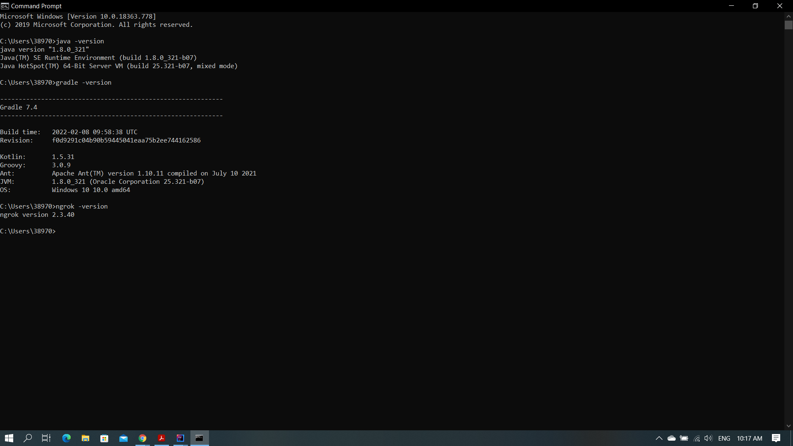

1. Create Github account and Twillio account.
2. Get first voice-enabled Twilio phone number.

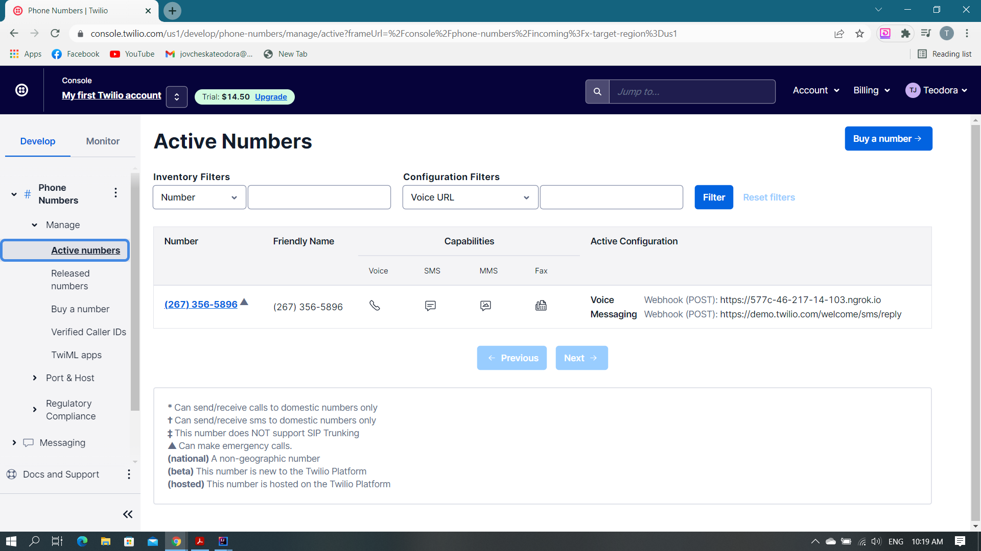

1. Setup development environment (Intellij) to make and receive phone calls.

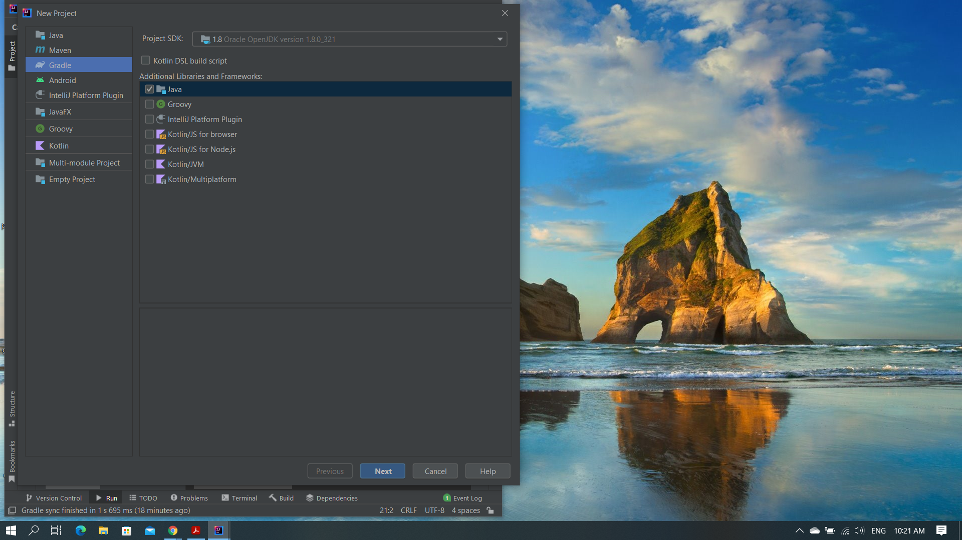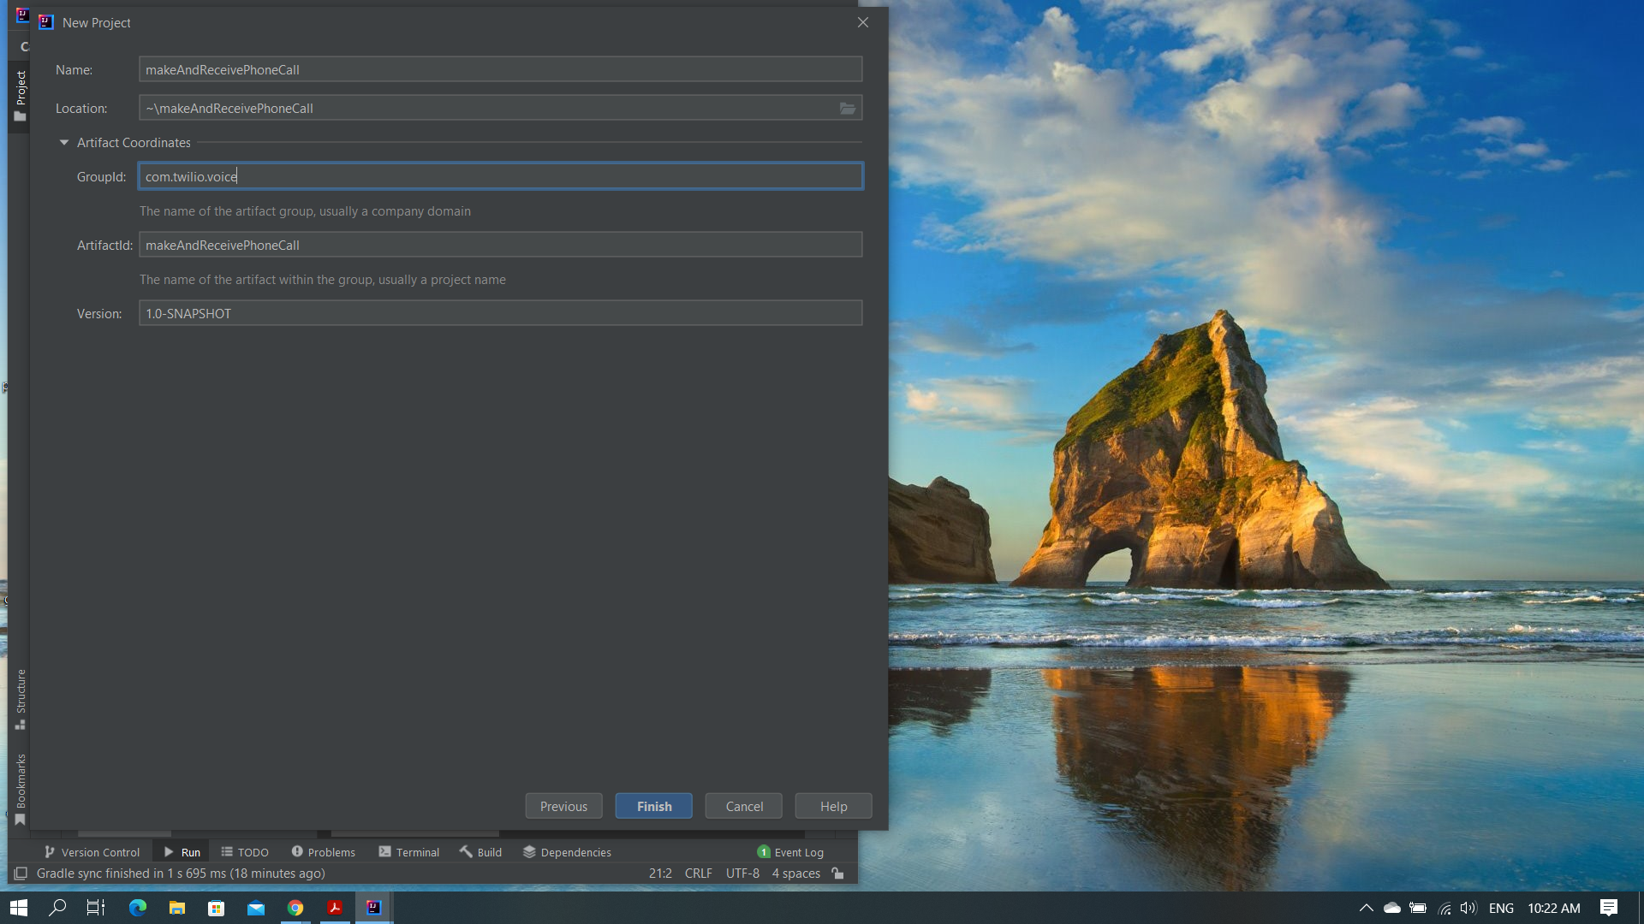

1. Download the standalone Twilio Java helper library with Gradle (with adding these dependency, Gradle will download the appropriate library and add to the classpath for building and running our Java application).

implementation group: "com.twilio.sdk", name: "twilio", version: "8.26.0"

1. Set up environment variables for my Twilio credentials and replace the placeholder credential values with my personal Twilio credentials.

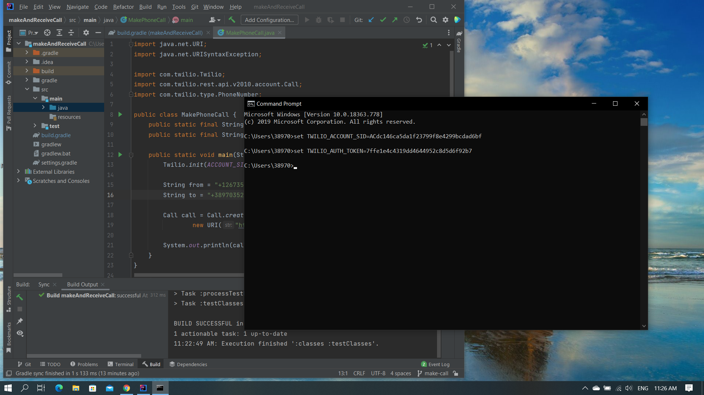

1. Add Spark Java web application and Slf4j as dependency in buld.gradle file (with these dependencies, Gradle will download the appropriate libraries and add to the classpath for building and running our Java application).

implementation group: "com.sparkjava", name: "spark-core", version: "2.7.1"

implementation group: "org.slf4j", name: "slf4j-simple", version: "1.7.21"

1. Allow Twilio to talk to my Java application with ngrok.
2. Exposing port 4567 to the public internet with ngrok.

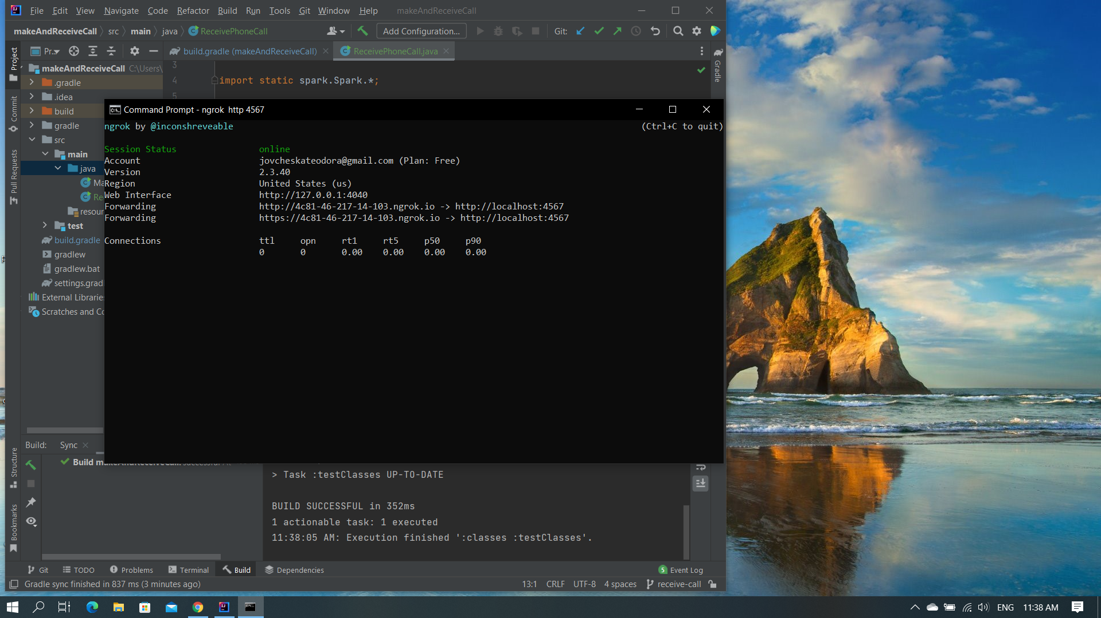

1. Configure webhook URL.

